**GREEN CAR TECHNOLOGY**

**ABSTRACT**

In the last few years, different attempts have been made in the transportation industry to combat the global warming concern. Numerous automobile companies around the globe have been trying different approaches to reduce the CO2 and other greenhouse gas emissions from their vehicles in an effort to reduce any hazardous effects to the environment. Greener vehicles which run on other forms of energy to produce electrical power instead of fuel have been tried and tested for the last decade. However, these approaches are still relatively new, expensive and may produce ineffective results as compared to a gasoline or diesel. Moreover, the approach is ineffective if the drivers are not informed or have no reason to care. Contributing to the Sustainable Development Goals, this paper proposes a program which uses cleaner, renewable energy alongside the standard fuel to produce a hybrid vehicle. This proposed system is an application that allows drivers to switch between fuel and electric energy to run their vehicles while monitoring and informing the vehicle owners of the CO2 emission reduced in a day. This paper discusses the details, algorithms applied in the interface such as stack and queue while also identifying the operations from the administrator’s perspective.

**Keywords –** CO2 Emission, Electrical Power, Fuel, Stack, Queue, Hybrid

# INTRODUCTION

Global warming is a worldwide concern that is increasingly becoming difficult to contain. As a result of growing atmospheric concentrations of greenhouse gases and continuous air pollution, there is a necessity to take action against global warming immediately. In the current times, the Earth’s average temperature is estimated to be about 1°C higher than pre-industrial levels [8]. The melting glaciers, rising sea levels, heat waves and other extreme weather conditions in different parts of the globe are evidence that climate change is impacting human environment in a negative manner [9]. Numerous challenges in human health, food and water security, economy and financial stability can be affected by natural disasters – floods, droughts, storms etc., originating directly from climate change. The rise in global temperatures across the planet is mainly caused because of air pollution. Presently, more than 90% of the Earth’s population live in conditions and places where the World Health Organization’s (WHO) standards and air quality limits are crossed [8]. The consequences of this serious environmental issue can be devastating to humans, with records indicating that approximately 4 million deaths due to respiratory, heart or lung diseases (cancer) [8]. Air pollution and climate change are mainly resultant from the same sources. The release of the greenhouse gases and air pollutants can be related to mechanical actions such as friction and abrasion. However, the main cause of the release is the combustion of hydrocarbons – fossil fuels or biomass especially from transport vehicles.

Transportation is one of the world's leading sources of the rise of greenhouse gases, with the number of vehicle emissions increasing year after year. The combustion of fossil fuels such as gasoline and diesel emit carbon dioxide, a greenhouse gas, into the atmosphere. Carbon dioxide (CO2) along with other greenhouse gases such as methane (CH4), nitrous oxide (N2O), and hydrofluorocarbons (HFCs) are causing the Earth's atmosphere to warm, resulting in the creation of the greenhouse effect. Transportation-related greenhouse gas (GHG) emissions account for approximately 27% of total US GHG emissions, making it the greatest producer of US GHG emissions [6]. GHG emissions in the transportation industry increased more than in any other sector between 1990 and 2020 [6]. The extraction, manufacture, and delivery of the fuel contribute about five pounds, whereas the vast majority of heat-trapping carbon pollution than 19 pounds per gallon comes directly from a car's tailpipe [7]. An increased drive for greener transportation began around 20 years ago when scientists gained a greater grasp of the impact of greenhouse gases on global warming. In 2015, over 190 countries worldwide signed the Paris Agreement, promising to drastically reduce greenhouse gas emissions [4]. From an objective standpoint, the best approach to reduce climate change and air pollution is to phase out burning hydrocarbons. It is easier said than done though. The combustion of biomass and fossil fuels are required for the global demand of energy generation, with the most polluting ones providing the most energy. There is a significant amount of pressure on industries - and entire countries - to invest in greener technologies to make electric vehicles. Governments are trying to endorse and commit to the Sustainable Development Goals Agenda as a global development agreement at the United Nations Headquarters (UN) [3].

In 2012, the Sustainable Development Goals (SDGs) were introduced across all countries as a commitment to addressing the world's most pressing issues - managing our fragile natural resources, promoting peace and inclusive societies, reducing inequalities etc. [2] The SDGs are a universal call to respond and achieve a model for shared prosperity. “Changing Our World: Agenda 2030 for Sustainable Development” aims to create a sustainable world leading to productive, healthy and peaceful lives on the planet. 17 main goals were declared and prioritized to solve the problems faced by millions of citizens across all continents [2].

Figure 1 SUSTAINABLE DEVELOPMENT GOALS (SDGs)

One of the listed SDGs is SDG 7 – Affordable and Clean Energy. Over the last 50 years, the global demand for energy has increased by over 185% [8]. Access to energy and transformation systems is a barrier to human and economic development. Solar, wind, hydropower, geothermal, biofuels, natural gas, coal, petroleum, and uranium are some of the renewable and non-renewable energy sources available in the environment that can be used instead of fossil fuels to reduce greenhouse gas emissions. Energy efficiency and increased use of renewables help to mitigate climate change and disaster risk [3].

Figure 2. SDG 7 – AFFORDABLE AND CLEAN ENERGY

In the transportation and vehicle industries, the thought of Electric vehicles (EVs) have surged in popularity and demand over the last decade. Electric vehicles can use solar, wind energy as well as hydropower as fuel, resulting in lower emissions than conventional vehicles. These cars emit little to no emissions while driving. EVs are expected to account for more than half of all cars sold in the world (approximately 54%) by 2040 [3]. Electric vehicles are directly aligned with the United Nations' global Sustainable Development Goals (SDGs), particularly SDG 7. However, there are still challenges and technical concerns with EVs. A major problem is that a single electric vehicle is considerably more expensive than fuel-driven vehicles. The average EV battery is currently estimated to cost approximately US $16,000, with EV manufacturing costing approximately $10,000 more than gasoline cars [3]. The transition to electric vehicles is ambitious, it is a massive and costly undertaking. Countries must be financially prepared for such a rapid transformation and be ready and willing to invest massively in this growing change.

The main objective of this research is to propose an alternative method to reduce carbon emissions from vehicles while promoting affordable and clean energy. Considering all the pros and cons of electric and fuel-driven vehicles, this paper looks into hybrid vehicles as a solution to the aforementioned problems leading to global warming. This approach is targeted towards car owners around the globe, wanting to make a positive change to the surroundings. The monitoring of exhaust emissions from cars, while they are operating normally on the road, is critical to any effective system for managing carbon emissions in the transportation industry. Therefore, the implementation of ‘GreenCar’ application allowing for drivers to monitor and control greenhouse gas emissions by switching between fuel and electric power is the demand of the situation.

# LITERATURE REVIEW

Solar power is the world's third most important renewable energy source today [3]. Customers can save money on fuel by switching to Solar Powered Motors. Solar power is regarded as essentially elegant in addition to being a sustainable energy technology. This means that no moving components or environmental emissions are produced during the conversion of sunlight to energy [3]. According to Fahim, Rahman, Karim [11], solar panels attached to the top of a vehicle will collect energy from the sun and convert it into usable electrical energy, which in turn will be stored in the lead acid batteries to be supplied to the motor when necessary. However, this whole process is dependent on the sunlight that hits the panels.

Batteries are a common method as to how electric cars are constructed. According to Larminie and Lowry [12], battery electric vehicles (BEV) can be divided into the electric battery, the electric motor, and the motor controller [12]. The battery charges with electricity either when plugged in the electricity grid via a charging device or during braking through recuperation. The issue with the BEVs are the sizes and expenses they come out as. Car size is most important to any BEV since the battery size must grow in parallel to the vehicle's weight. Larger cars need bigger and much more expensive batteries [13].

Research done by Prajapati, Patel, Sagar [14], indicated that another way to run electric vehicles is the use of ultracapacitors. Only the electric motor turns the wheels; the gasoline engine is only used to generate electricity. Series plug-ins can run solely on electricity until the battery needs to be recharged. The gasoline engine then generates electricity mechanically to power the electric motor.

Based on these studies, the electric or solar powered vehicles alone have more cons than pros. A hybrid vehicle is the most suitable solution to implement for this research. Hybrid Cars use no energy during idling state; they turn off and use less energy than petrol engines at low speeds. They will offer greater mileage than conventional cars with the noise pollution and emission of CO2 and greenhouse gases being considerably reduced.

# METHOD

In this particular study, a classic waterfall methodology was used to develop and create the desired application. The process involved performing the typical analysis, design, development, implementation, and evaluation (testing) phases of the ADDIE process. Described below are the stages in depth :

## ANALYSIS

During this phase, topics such as the problem statement, study objectives, scope and limitations were dealt with. During this phase, a tremendous amount of journals, articles, websites were researched to find the desired, viable solution that would benefit both the people and the environment in the vehicle industry. According to Global e-Sustainability poll results, 68% of smartphone users are eager to adopt behaviors that could result in even greater future reductions in personal carbon emissions [5]. The main purpose was always to take sustainable precautions against the threat of global warming by using cleaner energy alternatives. Thus, in the context of transportation vehicles, GreenCar Application can be a program implemented within drivers’ smartphones to provide some awareness and hopefully making the drivers more self-conscious and willing to do better for the environment each time they drive their vehicles. The software will be especially useful in converting a regular car into a "green" car with the main functions of the application being the ability to monitor, detect and calculate the CO2 emission reduction. The program presents control operations / mechanism that allows hybrid vehicles to switch control between a fuel-powered engine to the clean electrical-powered motor.

## DESIGN

In the design phase, the system flow of the entire application is mapped out using a flowchart. A flowchart is created to demonstrate all the paths and interfaces possible from the start to the ending process. The design also catered to different users. The application is obviously created for regular drivers, but consideration is also given to the administration side. The program allows a particular owner to login through their vehicle’s registration number and control the vehicle’s functions along with showing relevant details including car model, registration plate. The driver using the interface can decide when and where to stop or start the eco-friendly electric mode depending upon the battery percentage that is observed. The electric battery level drops or increases in real time based on the time and distance that the vehicle is running. Using the time, distance calculations are made and automatically updated after an engine is switched off – providing and displaying to the car owners the status of the reduction in CO2 emission.

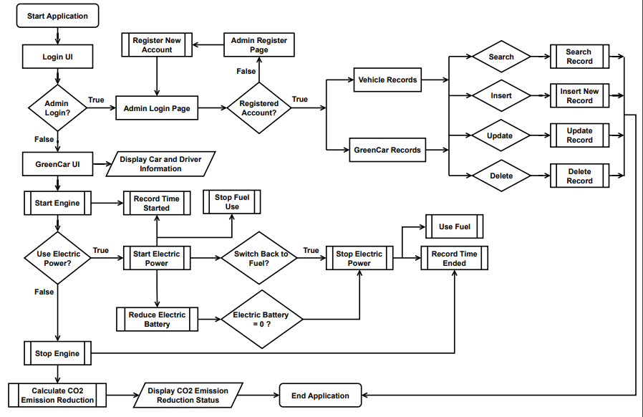These daily records of all GreenCar vehicles are stored in the administration database, such that authorized company personnel can track, graph, and record the usage and emission reduction of a particular vehicle. Additionally, admin users can track as well as manipulate – insert, delete, update any vehicle or GreenCar records through the Admin UI instead of searching through the original database.

Figure 3. FLOWCHART OF THE ENTIRE GREENCAR APPLICATION

## DEVELOPMENT

The development stage takes the plans created in the analysis and design phases and constructs the GreenCar Application as the flowchart depicts. An entire JAVA application prototype is developed to match the interface and functional requirements discussed in the design phase. Using Apache NetBeans IDE, the coding and the layout of all the application pages were done using JFrame classes. The reason for the use of JFrame classes is to produce a GUI that is easily accessible and usable to all users. Furthermore, it is a critical requirement to establish a GreenCar database. The database allows users to save, store and retrieve all the application records permanently for any future or real-time use. Thus, using MSSQL Server Studio the new database was created with three tables – Admin, Vehicle and Green.

## IMPLEMENTATION

Each GreenCar Application page is coded using standard JFrame form tools such as buttons, text boxes, panels, labels etc., and is directly associated to the GreenCar database. The GreenCar database is made of three tables that are related to one another, having their own specific attributes. The Admin table holds the records of the admin users. Information such as their User Id, first and last names, birthdate, email and the corresponding login passwords are safely stored on this private table. The Vehicle table stores the relevant information on the vehicle. The vehicle plate number, owner’s name as well as the model of the car are attributes to this table. Finally, the Green table in the database is used to record vehicles’ travel data. Attributes in this table specify the total distance covered, distance covered using electrical energy, CO2 emission reduction percentage for a single vehicle on a single day. This table holds a composite key with the date and the vehicle plate number together being unique for each record. All the data in these tables in the GreenCar database can be directly manipulated and accessed through the GreenCar Application.

Coming back to the GreenCar App, the system is divided into one main class which simply runs the application, combined with six JFrame application pages. The six JFrame classes are as follows:

1. **Admin Login Page**
2. **Admin Register Page**
3. **Vehicle Records**
4. **GreenCar Records**
5. **Login UI**
6. **GreenCar UI**

The Admin Login and Register Pages are designed as regular forms with textboxes for accepting input like id, password etc., along with appropriate buttons to perform the login and registering functions. Each id must be unique to one particular administrator. The registration page once filled in correctly and submitted, successfully saves the details into the GreenCar database under the Admin table. The admins, once registered or successfully logged in, can access the Vehicle Records or GreenCar Records pages. These application pages display the Vehicle and Green tables from the GreenCar database as part of the interface and allows administrators to view or perhaps even alter the data stored in the tables without actually interfering with the original database. Bothe the pages have textboxes and buttons for locating specific records. Admins can insert, update or delete records from using the corresponding buttons on the page.

The main application page is the GreenCar UI. This is the interface that allows all drivers to control how their car runs while driving once they have logged in through their vehicle number. The page displays all the details of the car such as car model, registration plate, emission status etc., pulled in from the corresponding records in the GreenCar database tables. Additionally, the user interface consists of start, stop, charge buttons that can be pressed to perform the car functionalities.

* **Start/Stop Engine** Button – The specific button on the UI can be pressed to either start or stop the car’s engine completely.
* **Start** Button – The Start Button activates the usage of electrical energy of the hybrid car instead of the regular motor energy which is suspended for the time being.
* **Stop** Button - The Stop Button halts the usage of electrical energy of the hybrid car switching back immediately to the regular motor energy.
* **Charge** Button – This specific button can be pressed to charge the electrical component of the car, to build electric energy or to stop charging once it reaches a desired, decent percentage.

One particular JFrame tool that is unique and absolutely essential to this application is the progress bar. A progress bar is a necessary code to indicate the electric battery level, pivotal to emission calculations. The electric battery level and other components such as time and distance covered in total as well as the coverage using electrical power is coded using specific data structures and algorithms in this program. The data structures used to perform the necessary calculations and operations are **Stack** and **Queue**.

**Stack** is an abstract data type that stores items in an ordered, linear sequence. A stack follows the Last-In-First-Out (LIFO) structure. A stack of plates is a real-world example: where it is only possible to take a plate from the top of the stack and also add a plate to the top of the stack. To reach a plate that is not at the top of the stack, all the plates above must be removed before actually getting the needed item . In the same way, in coding terms, it is only possible to access the element at the top of a stack data structure. The last element added will be the first to be removed. As a result, to implement a stack, we must keep a pointer and either push or pop to and from the top of Icon
the stack.

Figure 4. STACK DATA STRUCTURE

The other data structure used in this study is **Queue**. Queues are abstract data structures that are like Stacks. However, unlike a stack, queues are open at both ends. One end (rear) is always used to insert data (enqueue), while the other end (front) is required to remove data (dequeue). The queue employs the First-In-First-Out (FIFO) method, which means that the data item stored first will be accessed first.

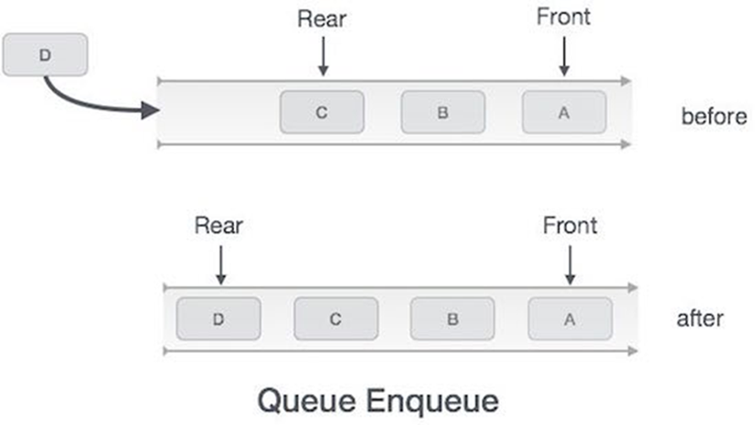

Figure 5. QUEUE DATA STRUCTURE

The specification of how stacks and queues are applied in the GreenCar UI is described below :

* Queue **q** (type : Integer) – Used for storing the electric battery level if the electric energy has been used in a single or multiple runs on a single drive. The queue is also used to shift from electrical to engine and vice versa.
* Stack **stack** (type : Integer) – Used to hold the all the possible battery percentage levels from 1 to 100.
* Stack **electrictime** (type : Real) **–** This specific stack is used to record the starting and ending times of the electrical energy is used (Time the vehicle uses electrical energy, which is necessary for the calculation of the distance covered by the vehicle using electrical energy).
* Stack **enginetime** (type : Real) - This specific stack is used to record the starting and ending times of the engine (Time the vehicle is running, which is necessary for the calculation of the total distance covered by the vehicle.).
* Queue **elDistance** (type : Real) – Storing the total distance covered using electrical energy in a single day.

The battery level is reduced and charged using threads, which are continuous running functions that update data in real-time. For this prototype application, the battery level value decreases by 1% each second once the electrical component has been started. The charging also works in the same manner, with the battery value increasing by 1% each second. Car owners can visibly see the dropping or increasing energy bar values while using the application using the following threads:

* **chargeThread** – Applied for charging.
* **t** – To reduce battery level over time.

Currently, the average range of electric cars (mileage) is said to be increasing with gradual growth in the technology. There are a few factors that affect this range – some of them being weather, battery size. Typically, drivers of these cars can expect to travel an average of 250 miles through a single complete charge [10]. Since the GreenCar application is meant to work with hybrid cars, the prototype interface considers the total distance covered from 100% to 0% to be a total of 225 miles. The distance covered to drop 1% of electric battery would be 2.25 miles. Thus, in this GreenCar Application prototype each time the electrical component is activated, one second is equal to 2.25 miles being covered by the particular vehicle.

The measurement of the different distances is required in this coding to calculate the CO2 emission reduction percentage. The formula that is applied in the coding is as specified:

Drivers and car owners may tend not to understand and care for the actual percentage. So, to make it simpler for regular people, the interface displays the reduction percentage as a status. There are three categories for the CO2 emission reduction status :

* **POOR STATUS -** CO2 emission reduction % is less than or equal to 30%.
* **GOOD STATUS -** CO2 emission reduction % between 30% and 75%.
* **EXCELLENT STATUS -** CO2 emission reduction % is greater than or equal to 75%.

All these records are updated into the Green table in the GreenCar database – CO2 emission reduction percentage, remaining battery, total distance covered, distance covered using electrical energy are the attributes logged with the current date and vehicle plate number. The process is instantaneous once the vehicle’s engine is switched off.

Other variables that are used in the coding :

* **date** – to store immediate time in HH:MM:SS format.
* **hours** – coverts the hours part of ‘date’ into seconds.
* **mins** – converts the minutes part of ‘date’ into seconds.
* **seconds** – receives the seconds segment of ‘date’.
* **total** – stores the value of ‘date’ completely in seconds.
* **battery –** holds the current battery percentage (peek of **stack**).
* **startTime** – current time when either the engine or electrical power has been started.
* **endTime** - current time when either the engine or electrical power has been stopped.
* **electricTime** – stores the total time electrical energy is used.
* **engineTime** - stores the total time the engine runs.
* **electricalDistance** - stores the total distance covered by a vehicle using electrical energy on one drive.
* **engineDistance** - stores the total distance covered by the vehicle on one drive.
* **enDist -** stores the total distance covered by the vehicle (**engineDistance** parameter in updateStatus procedure) for a whole day.
* **carbon –** percentage of CO2 emission reduction.
* **totalElectric -** total distance covered by a vehicle using electrical energy in a day.
* **date_time** – current date (DD/MM/YYYY)
* **car_plateid** – plate number
* **yesterdayDate –** stores yesterday’s date (DD/MM/YYYY)

## EVALUATION

Once the GreenCar Application is fully designed and developed, all the interfaces must be tested individually as well as completely together. The login and registration pages must be tested to check whether the operations are successful corresponding with the data that is stored in the GreenCar database. After logging in, information regarding the specific vehicle – battery level, owner name, model, emission status all must be displayed correctly on the GreenCar UI page. When registering, there must be consideration to having a unique id. The input for id and password while logging in must be synonymous to one record, providing an error in case both the values do not match. The buttons in the GreenCar UI must work as intended, with the timers starting and recording at the precise times of the button clicks. The stacks, queues, threads all must be tested one after the another to check whether items such as battery level, starting and ending can be pushed, popped, enqueued and dequeued at the appropriate situations. The calculations for the emission reduction must be timed properly and cross checked to ensure that the data and percentage values are accurate before being saved into the database tables. Additionally, the emission status must be displayed correctly accordingly. Another critical point of the evaluation stage is the ability to update. The application must be tested to ensure that the data recorded previously can be retrieved in a proper manner and updated even further. The tables in the Vehicle Records, GreenCar Records pages as well as the original database tables need to be able to revise the records and simply not add records each time. Furthermore, the delete, search and insert functions should also be checked. After conducting all these tests, can we completely make sure that the prototype works as discussed in the previous stages of the development process.

# RESULT & DISCUSSION

## Admin Login Page

Figure 6 represents the final interface design of the Admin Login Page as part of the GreenCar Application. A registered admin is presented with two options – to either enter their credentials and press the login button or register a new account for a new administrator.

Figure 6. ADMIN LOGIN PAGE DISPLAY

If the administrator enters a valid user id and the corresponding password in the text fields and presses the ‘Login’ button, they are directed straight to the Vehicle Records Page. Otherwise, an error message is displayed prompting them to enter the correct information or register a new account. On the other hand, if an administrator decides to press the ‘Register New Account’ button, they are directed to the Admin Register Page.

## Admin Register Page

The Admin register page displayed below is designed to resemble a typical web form. New administrators can enter their personal information in the correct text fields so that it can be stored in the database for any future usage.

Figure 7. ADMIN REGISTER PAGE DISPLAY

More importantly, while registering admins need to enter and create their own exclusive user id. This id has to be unique and cannot be one that is already recorded within the database. To complete the registration, the user must also create their own password and enter it an additional time for verification. The information in the fields is only registered permanently if and only if the user id is unique, password entered in the password field and the confirm password field are the same. Any unsatisfied condition and the system will prompt an error message. Once the ‘Register’ button is pressed, a new record is created for the Admin Table in the GreenCar database, and the user is directed back to the Admin Login Page.

## Vehicle Records

Administrators use this page to search and keep track of all the vehicles that are stored in the GreenCar database. Users can search for a specific vehicle by inputting the plate number of the vehicle into the correct text field or scroll through the list of vehicles and find the desired record. Moreover, on this page admin users can enter new records, update existing ones or even delete certain rows from the Vehicle Table in the GreenCar database. To execute the changes in the database rows, the correct buttons are pressed depending on the operation – Insert, Update or Delete.

Figure 8. VEHICLE RECORDS DISPLAY

## GreenCar Records

Similar to the Vehicle Records page, this page displays the data from the Green table in the GreenCar database. Administrators can check the daily driving records for all the vehicles. The information on the distance and emission reduction percentage can be searched using the date and vehicle plate number. The operations and buttons are the same as the Vehicle Records page with the updates being executed in the Green table here. The panel on the left of the application has buttons allowing admins to switch between the ‘Vehicle Records’ and ‘GreenCar Records’. This

panel exists on both pages for the purpose of navigation. Typically, there is no need to update, insert records manually. However, in case the automatic system fails, administrators can use this page.

Figure 10. LOGIN UI DISPLAY

Figure 9. GREENCAR RECORDS DISPLAY

## Diagram Description automatically generatedLogin UI

The Login UI has only one purpose. Regular drivers and car owners can enter their vehicle plate number to access the GreenCar UI. If the vehicle number input is registered, the driver is directed to the user interface where they can control and view the different operations that can be executed.

## GreenCarUI

Figure 11 reveals how the GreenCarUI application page initially looks like. Based on the plate number input on the Login UI page, this page displays the plate number and the corresponding car model as well as the owner name from the database. The initial page also contains simply the emission status bar, battery value / progress bar with one button to start the vehicle – ‘Start / Stop Engine’.

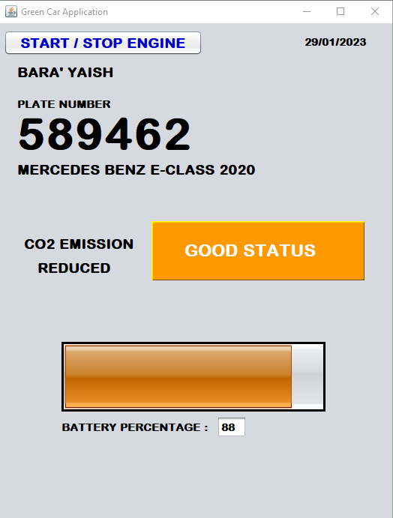

Figure 11. INITIAL GREENCAR UI DISPLAY

The interface shows the battery level in both a numeric value as well as a progress bar. The battery level in the beginning depends on a few factors. The level of battery first depends on whether the vehicle has been previously used on the same day. If so, the value must be retrieved back from where it last left off. The value is regained from the stored record in the Green table and the progress bar filled to that point. If the vehicle has not been used at all on the particular day, the database is checked to see if the vehicle was used on the previous date. If so, the battery level from yesterday is retrieved else the battery level is set to a 100% in this prototype interface. The emission status also depends on these same factors. If the car has been used previously in the day, the status is retrieved back depending on the CO2 emission reduction percentage previously recorded. In the case, the vehicle is not used on the day, the default status will be displayed as GOOD.

Figure 12 displays the interface once the engine is turned on.

Figure 12. GREENCAR UI DISPLAY

On pressing the ‘Start / Stop Engine’ button, the GreenCar UI should reveal some hidden interface buttons as well as record the time the engine starts up. These buttons are specific to the electrical component of the hybrid vehicle. Three buttons are presented to the drivers – Start, Stop, Charge to perform the obviously stated operations. If the ‘Start’ button is pressed, the queues that control the functions start working to switch from fuel energy to electrical energy. The stack that controls the battery values starts popping and decreasing the value one by one each second. The time the ‘Start’ button is pushed and recorded into a separate stack.

To stop the electrical power and revert back to fuel, the ‘End’ button must be pressed. The queue will enqueue the fuel energy to the front and push the electrical power to the rear of the queue. The battery level will stop reducing any further and halt the stack. The specific time the ‘End’ button is pressed is pushed into the same stack with the Start time and then both elements in the stack are popped to evaluate the time difference between them for the calculation of the electrical distances.

Pressing the ‘Charge’ button once pushes values into the battery stack and increases the battery percentage one by one. Clicking on the same button again stops the process. Once the ‘Start / Stop Engine’ is pressed again, the buttons are once again hidden and unavailable to use and the timer again records and pushes the instant time when the engine is turned off. The stack that holds the engine start time and end time are popped until empty to calculate the time difference between them for the calculation of the total distances and therefore emission calculations. These records are then correctly and immediately recorded onto the Green Table in the GreenCar database. The table below displays some experimental values and results to indicate whether the calculations are accurately displaying the correct results.

|  |  |  |  |  |  |
| --- | --- | --- | --- | --- | --- |
| S.No | Time Electrical Power is Used (s) | Total Time Traveled (s) | Distance Covered using Electrical Energy (miles) | Total Distance Covered (miles) | CO2 Emission Reduction % |
| 1. | 6 | 10 | 13.5 | 22.5 | 60.0 |
| 2. | 40 | 181 | 90.0 | 407.25 | 22.099... |
| 3. | 29 | 85 | 65.25 | 191.25 | 34.117... |
| 4. | 17 | 21 | 38.25 | 47.25 | 80.95 |

The results of the experiment indicate that the calculations and the data that is being recorded into the database is completely accurate. The table results identify that the stacks, queues correctly work, with the timings being recorded properly and the distances and emission calculations working precisely due to the operational formulae.

# CONCLUSION

## SUMMARY

Sustainable Development Goal 7 - Affordable and Clean Energy is one of the standardized sustainable development goals, aiming to develop a much brighter and more sustainable nation. The goal of this initiative is to reduce carbon dioxide emissions into the atmosphere by encouraging and increasing the use of cleaner renewable energy instead of completely being dependent on fuel. Even though it is difficult, the aim is to reduce fuel consumption, thus decreasing the carbon emissions into the atmosphere. As a result, this study focuses on hybrid vehicles that demonstrates simple application interfaces through which users and administrators can track their car CO2 emission and electric battery consumption levels. The proposed system implements stack data structures to control the battery values and queue algorithms in a hybrid vehicle prototype to switch control from engine to electric motor and vice versa.

## FUTURE WORK

The Internet of Things (IoT) is defined by Gartner as "a network of physical items that incorporate embedded technology to communicate, detect, or interact with their internal states or the external environment. [5] " As sensors extend across practically every industry, the Internet of Things (IoT) causes a large influx of Big Data and is a fundamental driver of the Big Data phenomenon [5]. The automotive industry is one of the industries most affected by IoT. Smart technologies enable the manufacture of highly automated and connected automobiles through GPS navigation systems. Millions of cars have recently been reported to be connected to the Internet, with the number projected to rise to hundreds of millions in the near future [5]. Thus, it will be the natural flow to implement the proposed system with IoT in the near future.

One of the driving factors that might cause an interruption is the technological readiness of the country where the solution would be implemented. Hybrid cars require charging for the electrical power; therefore, it is crucial that either the technological infrastructure is ready or there is al alternative method to achieve the charging of the electrical battery. Facilitating an efficient and sufficient number of charging stations in the countries is a complete necessity [15]. The development and creation of these charging centers depends on the country, their government such that is not completely in our hands. Therefore, the system must be able to receive and convert energy from other sources such as sunlight, wind, hydropower etc. In the future, it might be essential to achieve and convert the electrical energy from all possible sources instead of just one or two to be an extremely efficient hybrid car. The hybrid car is a bridge to the final destination – vehicles being completely free and independent from fuel.

# REFERENCES

1. T. Hák, S. Janoušková, and B. Moldan, “Sustainable Development Goals: A need for relevant indicators,” Ecological Indicators, vol. 60, no. 2, pp. 565–573, Jan. 2016, doi: 10.1016/j.ecolind.2015.08.003.60.
2. “What is SDGs? – ITB SDGs Network,” Itb.ac.id, 2015. https://sdgsc.itb.ac.id/what-is-sdgs/
3. UNEP, “GOAL 7: Affordable and clean energy,” UNEP - UN Environment Programme, Oct. 02, 2017. https://www.unep.org/explore-topics/sustainable-development-goals/why-do-sustainable-development-goals-matter/goal-7
4. Tsokov, Tsvetan & Petrova-Antonova, Dessislava. (2018). Monitoring and Control of Vehicles’ Carbon Emissions, doi: 10.1007/978-3-319-93641-3_11.
5. Internet of Things, a key lever to reduce CO2 emissions, 2015 | Available: http://www.atkearney.fr/documents/877508/879237/20151113_IoT+Impact+on+en-ergy_Europe+EN.pdf/6757111f-21da-49ee-82fd-915ff42dc26d.
6. Carbon Pollution from Transportation | US EPA,” US EPA, Jun. 08, 2018. https://www.epa.gov/transportation-air-pollution-and-climate-change/carbon-pollution-transportation
7. “Car Emissions and Global Warming,” Union of Concerned Scientists, Jul. 18, 2014. https://www.ucsusa.org/resources/car-emissions-global-warming
8. H. Akasha, O. Ghaffarpasand, and F. Pope, “Climate Change and Air Pollution.” [Online]. Available: https://opendocs.ids.ac.uk/opendocs/bitstream/handle/20.500.12413/16600/962_Climate_Change_and_Air_Pollution.pdf
9. G. D’Amato and C. A. Akdis, “Global warming, climate change, air pollution and allergies,” Allergy, vol. 75, no. 9, Aug. 2020, doi: 10.1111/all.14527.
10. “Electric Car Range: How Far Can An EV Go In One Charge? | CU SoCal,” www.cusocal.org. https://www.cusocal.org/Learn/Financial-Guidance/Blog/how-far-can-an-electric-car-go#:~:text=Electric%20vehicle%20(EV)%20driving%20range
11. SOLAR_CAR [Online] | Available : https://www.researchgate.net/publication/337338929
12. Larminie J, Lowry J: Electric & Hybrid Vehicle Technology International,” Electric and Hybrid Vehicle Technology International, vol. 2021, no. 1, pp. 144–144, Mar. 2021, doi: 10.12968/s1467-5560(23)60040-5.
13. E. Helmers and P. Marx, “Electric cars: technical characteristics and environmental impacts,” Environmental Sciences Europe, vol. 24, no. 1, Apr. 2012, doi: 10.1186/2190-4715-24-14.
14. R. Sagar, “Hybrid Vehicle: A Study on Technology,” ESRSA Publications Pvt. Ltd., vol. 3, no. 12, pp. 1076–1082, Dec. 2014, Accessed: Jan. 30, 2023. [Online]. Available: https://www.academia.edu/61554663/Hybrid_Vehicle_A_Study_on_Technology
15. Electric Car Introduction [Online] | https://www.researchgate.net/publication/361101737